**<A>**

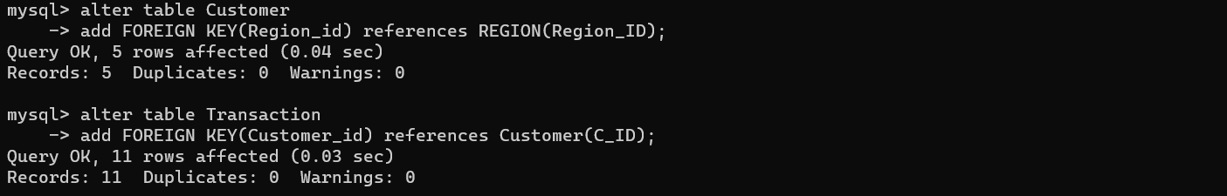

How many days on average are customers reallocated to a different region?

What is the closing balance for each customer at the end of the month?

Closing balance for each customer at the end (assume a base balance of 10000 before transaction)?

Creating views for transaction type

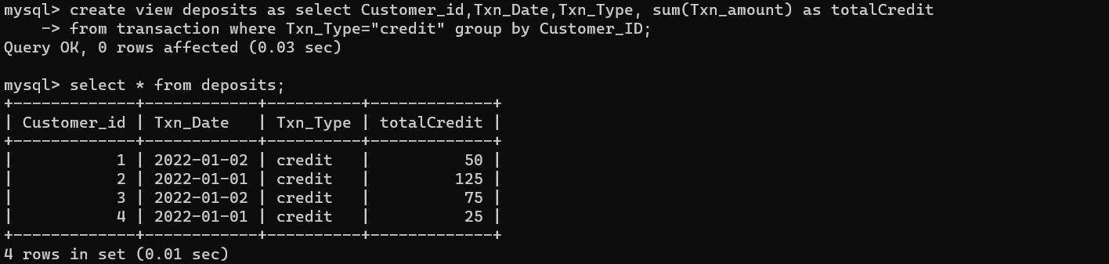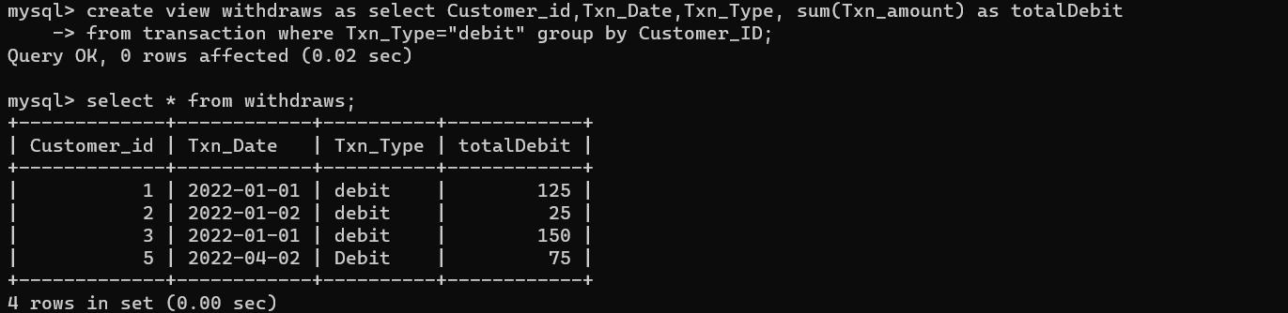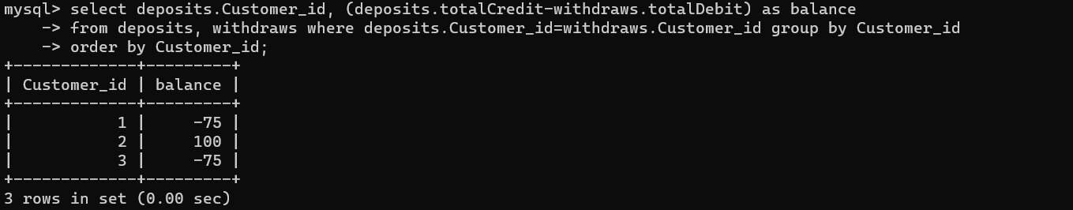

**<B>**

Create a procedure which would take input the section for ex ‘A’,’B’ etc and returns back count of students who have minimum of 85% attendance and marks are above 75%(ie above 350 marks)

